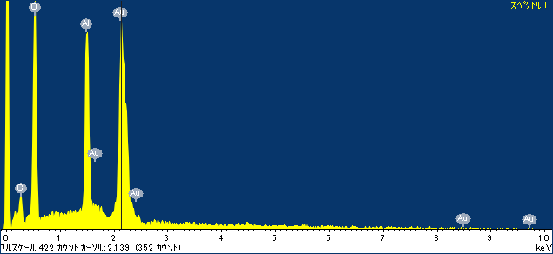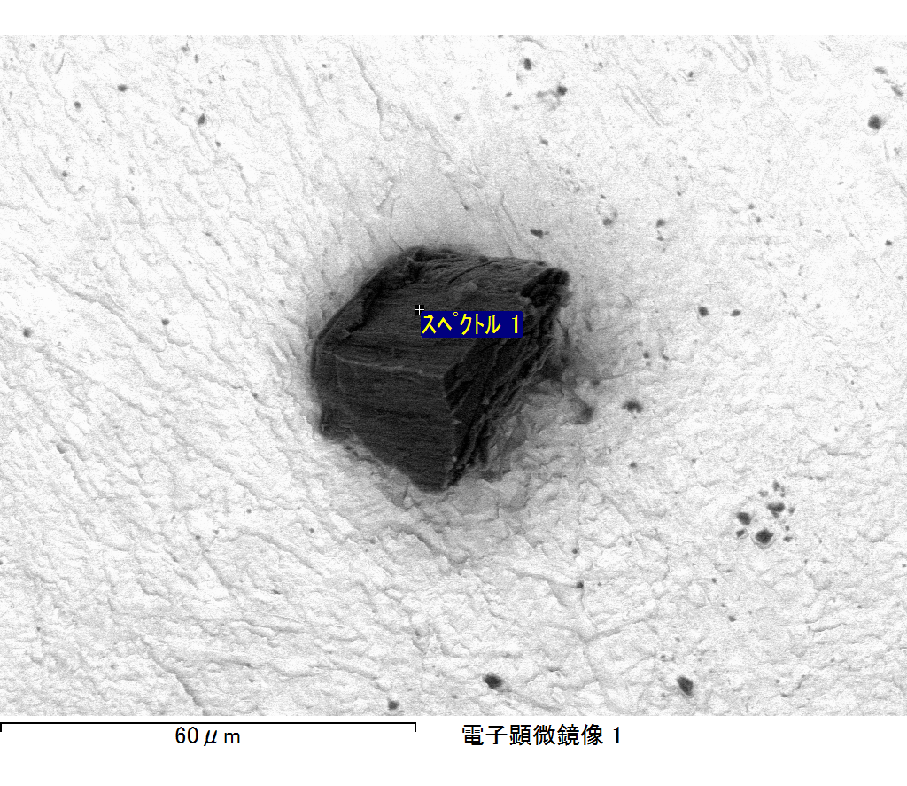

ｺﾒﾝﾄ :

2017/11/01 12:54:27

ﾌﾟﾛｼﾞｪｸﾄ 1

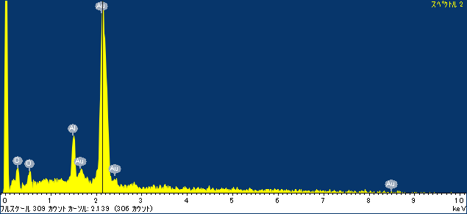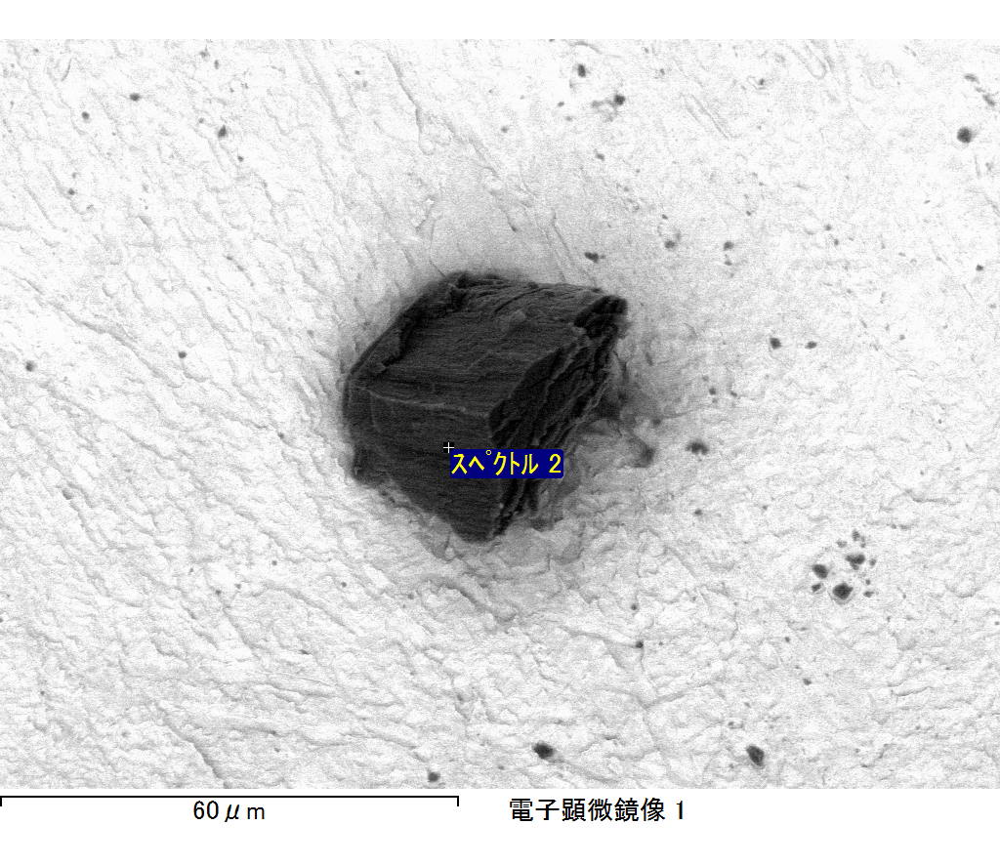

ｺﾒﾝﾄ :

2017/11/01 12:54:31

ﾌﾟﾛｼﾞｪｸﾄ 1

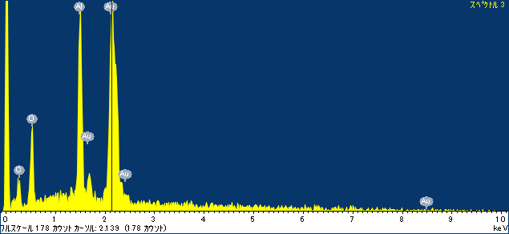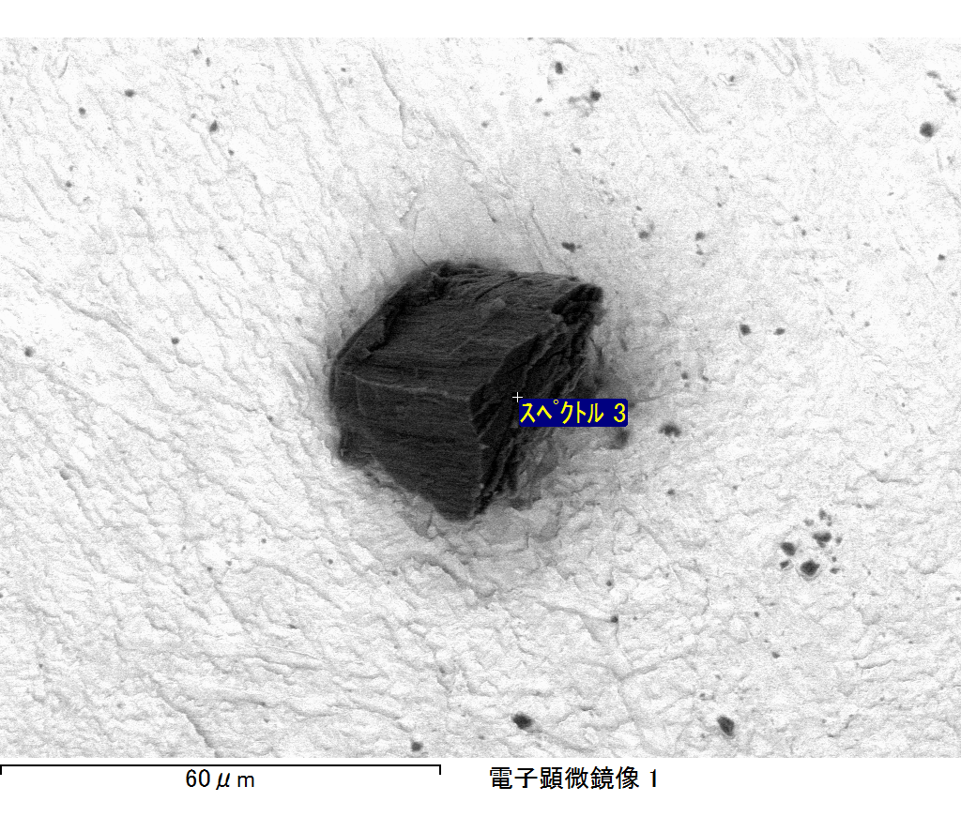

ｺﾒﾝﾄ :

2017/11/01 12:54:40

ﾌﾟﾛｼﾞｪｸﾄ 1